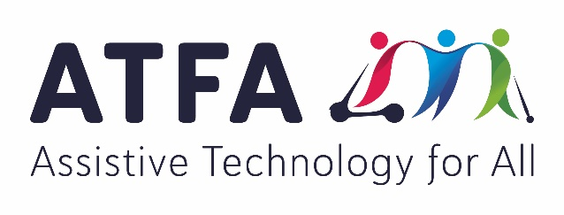
Share your story about accessing assistive technology outside the National Disability Insurance Scheme

Background:
The term “assistive technology” refers to any aid, piece of equipment or home modification that helps someone with disability perform an everyday task. Some examples include:
- A device to help someone turn the pages of a book
- A wheelchair to assist with mobility
- A prosthetic limb to replace a missing body part
- A splint to overcome lost muscle strength and enable someone to walk
- An electronic communication device to be the voice of someone who cannot speak
- Screen reading software to assist someone to navigate a computer without vision
- A hoist to help someone with limited mobility to get in and out of bed
- A ramp to allow someone with limited mobility to gain access to their home
- And much, much more!

The Assistive Technology For All (ATFA) Alliance believes that everyone who needs assistive technology should be able to access it. That’s why we’re asking the Australian Government to establish a national assistive technology program to meet the needs of people with disability who are excluded from the National Disability Insurance Scheme (NDIS). You can find out more about the Assistive Technology For All campaign by visiting www.assistivetechforall.org.au.

Are you a person with disability?
Have you been excluded from the NDIS?
Have you had difficulty accessing the assistive technology you need elsewhere?

If you answered yes to these questions, we’d love to hear from you. By sharing your story, you can help us ensure that everyone who needs assistive technology can access it into the future.

Instructions:
- By completing and returning this document, you are giving permission for your story to be published in association with the Assistive Technology For All campaign. We will contact you before we publish your story to make sure you are happy with this.
- The questions included in this document are only a guide. You don’t need to answer all of them, just the ones that relate to you. The main things we want to know about are the barriers you’ve faced when trying to access assistive technology and the impact this has had on your life.
- If you have any questions, please contact Assistive Technology for All Coordinator, Lauren Henley. Lauren can be contacted on (03) 9655 2140.
- Once completed, please send this document to info@assistivetech.org.au.

Your details:
Name:
Contact number:
Email address (if applicable):

Thank you for sharing your story with us. It will help us make sure that everyone who needs assistive technology can access it into the future. The following headings and questions are just prompts to help you tell your story. You don’t have to answer all of the questions listed here – only the ones that you want to respond to.

Tell us about yourself:
- Where do you live?
- How old are you
- What type of disability do you have?
- How and when was your disability acquired?
- What activities are you involved in at home and in your community?

Tell us about the assistive technology that makes a difference in your life:
- What assistive technology do you use or need?
- What tasks does it help you with?

Tell us how your assistive technology has been paid for:
- Have you accessed funding through a Government program? For example, a state-based aids and equipment program, the Commonwealth Continuity Program or an aged care package?
- Could the full cost of your assistive technology be met under this program, or did you still need to pay something?
- Was there any assistive technology you needed that could not be funded under this program?
- If you have had to pay for some or all of your assistive technology, how much did this cost?
- Have you had to go without other services or supports so you could afford the assistive technology you needed?

Tell us about any other barriers you’ve faced when trying to access assistive technology:
- Have you found it easy to understand what assistive technology is available?
- Have you had access to equipment trials and demonstrations?
- Have you had to wait very long to access the assistive technology you’ve needed?
- Have you had access to training to help you get the most out of your assistive technology?
- Have you had access to equipment upgrades, maintenance and repairs?

If you haven’t been able to access assistive technology when you’ve needed it, tell us what impact this has had on your life:
- Has it limited your independence?
- Has it meant that you’ve had to rely on other people for support?
- Has it affected your health and wellbeing?
- Has it prevented you from participating in community activities?
- Has it had any impact on your family or friends?

Tell us what you know about how your needs would have been met under the NDIS:
- Do you know anyone with similar needs who has received assistive technology under the NDIS?
- How has their experience differed from yours?
- Is there anything you would like to tell the Government about the situation for people with disability who are excluded from the NDIS?

